About The Weald School

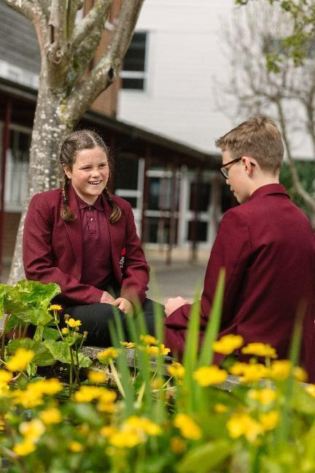
The Weald School is an 11-18 mixed comprehensive with around 1,800 students. This includes a thriving Sixth Form of about 300 students. Our students are at the heart of all that we do. The Weald is a warm, friendly and vibrant school at the centre of the community with a wonderful family feel, where each student is known and cared for. Students are well behaved, have a very positive attitude and enjoy coming to school. There are excellent relationships between staff and students. We believe that all our students have the potential for excellence. We work towards this by having high expectations of students and staff, by continually raising aspirations and by promoting our students’ self-belief alongside strong moral values.
Academic outcomes at The Weald are consistently high. In the summer of 2025, our Year 13 students achieved results which put us, yet again, in the top 10% of all schools and colleges nationally. 95% of our students applying to university secured their first choices.

Our Year 11 students also attained excellent results: our most recent Progress 8 measure (from 2024*) is +0.43, meaning that our students typically make, on average, almost half of a grade more progress in each GCSE than students in the rest of the UK.

These results follow an upward trend of improving results over time and underpins our ethos of striving for academic success alongside character education.
* There are no Progress 8 measures for 2025 due to students not sitting Year 6 SATS.
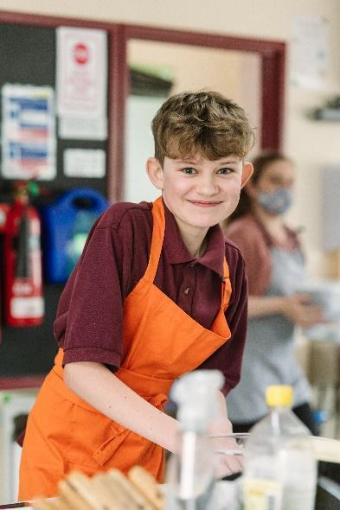
Our curriculum is broad and balanced and offers many exciting opportunities for all students, both in school and out. Students study Key Stage 4 over three years. This presents real opportunities for creativity and varied approaches to learning through both GCSE and BTEC vocational qualifications. There are tremendous extracurricular opportunities at The Weald through sport, performing arts, Radio Weald, Weald TV, links with partner schools in Europe and Africa, the Duke of Edinburgh award, as well as a number of other trips. In short, we believe there is something for everyone at the school.


We believe achievement is not just about qualifications. Personal development is key to what we do. We have a very active School Council and a strong student voice within the school. We also have a close and effective partnership with our parents and carers. We listen to their views and use them to inform the work of the school. Attendance at school events is high, and an effective governing body has a full representation of parents.
I genuinely feel it is an honour and privilege for me to be able to lead and develop further the education of the children at The Weald. Our students are a joy to work with. Visitors describe them as polite, courteous and respectful, making the school a fantastic place both to study as a student, and to work as a member of staff.
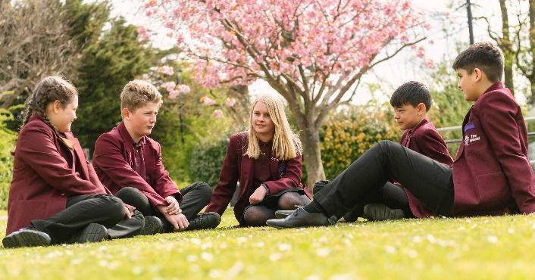
About the school
The Weald School serves the local community from a pleasant 25-acre site on the edge of Billingshurst. Our size offers us many advantages. We have excellent facilities, allowing us to offer a wide and varied range of academic and vocational courses at all levels. The Weald campus has been steadily improved in recent years.
An £11m expansion programme completed in 2017 funded a new teaching block for maths and art and a 400-seat dining facility. Additional improvements include new science laboratories, media room and TV studio, changing rooms, drama suite, music block and a pastoral provision area. There is also a swimming pool and fitness centre (adjoining the school site and run by DC Leisure / Horsham District Council), and two multi-use games areas.
The Weald School offers all students:
- A well-planned, broad and balanced curriculum
- A record of excellent examination results
- Well qualified specialist staff combining innovative and traditional methods in the classroom
- A secure, supportive, encouraging and happy environment
- A wide range of extra-curricular and residential activities.
What our students think about the school:
- “Lessons are fun, and the school has a good atmosphere” – Year 7 student
- “The teachers have a good attitude to learning and we are encouraged and can hold our own opinions” – Year 10 student
- “We are able to talk to our teachers about issues and they make a real difference in our lives” – Year 9 student
- "I love the opportunities we get to work with younger students - it's great fun and really rewarding to support them with different aspects of their work." - Year 12 student
- "There is fantastic support for researching progression options for when we move on from the Sixth Form. The Sixth Form staff are always there to help with the UCAS process." - Year 13 student
Sarah Edwards
Headteacher
September 2025

